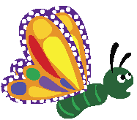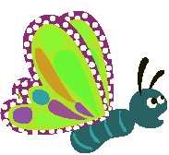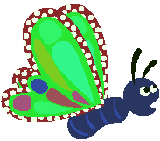 | Butterfly Effects  This project makes a butterfly change colour every time you press the spacebar.
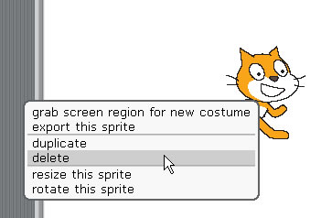 | RIGHT mouse click on the cat and click 'delete'
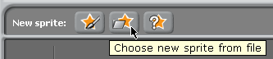 | Click ‘Choose new sprite from file’
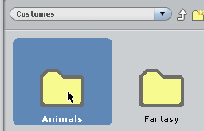 | Double click the ‘Animals’ folder
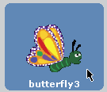 | Click on ‘butterfly3’
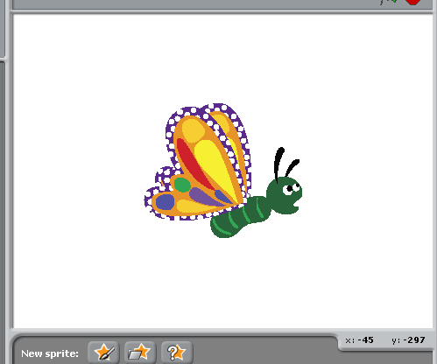 | Click ok.  The butterfly sprite will now appear on the stage.
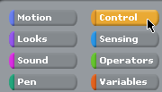 | Click the ‘Control’ option.
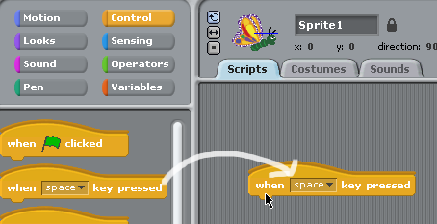 | Drag the ‘When [space] key pressed block from the LEFT into the ‘Scripts’ area.
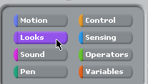 | Click on the ‘Looks’ option.
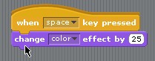 | Drag the ‘change [color] effect by [25] option so that it snaps into place.
Press the spacebar – see what happens!

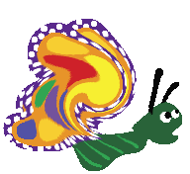 | Butterfly Effects 2  This project changes the ‘effect’ depending on where the mouse moves.  This assumes you have completed the above.
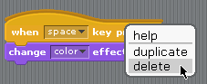 | RIGHT mouse click on the blocks and click ‘delete’
 | Click the ‘control’ option
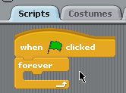 | Drag the below blocks into the ‘scripts’ area as shown.
 | Click the ‘looks’ button
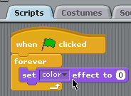 | Add the block as shown.
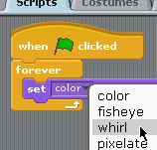 | Change the dropdown option to ‘whirl’.
 | Click on ‘Sensing’
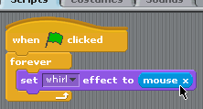 | Drag the ‘mouse x’ into the place where the ‘0’ was.
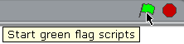 | Click the green flag to start your script.
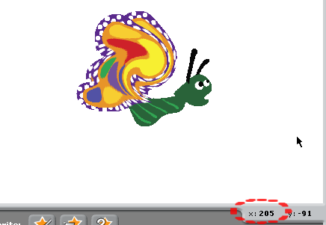 | Note how when you move your mouse left and right (change the x position) that the effect changes.
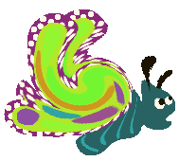 | More effects…  The below will make the butterfly change colour as the mouse moves up and down (y axis)
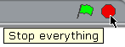 | Click the red circle to stop the script.
 | Click on ‘looks’
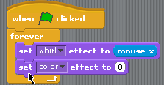 | Add ‘change colour’ effect
 | Click on ‘Sensing’
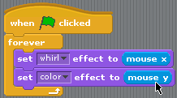 | This time, drag in ‘mouse y’ as shown.
 | Click the green flag to start your script.
Experiment by changing the effects

Making it more interactive…
Click the red circle to stop the script.
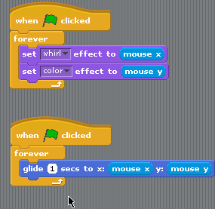 | Add the second set of blocks as shown.  When there are TWO lots of code that seamlessly run at once, they are called threads.
SAVE YOUR WORK

Press ALT+Print SCREEN to capture the work you’ve done today.
PASTE it into your project diary.

